**Assembly Assignments**

The assignments are individual tasks; you have to do these codes by yourself.

1. Take five inputs and calculate 1st subtract, then sum, then subtract then sum.

**Input and Output:** 8 3 **5** 2 **7** 1 **6** 2 **8**

**Explain:** 8 – 3 = 5 + 2 = 7 – 1 = 6 + 2 = 8

1. Write a single program which will take uppercase string and print the string to lowercase then take lowercase string input and print uppercase of the string.

**Input Length of Upper String:** 4

**Input Enter String Here:** ULAB

**Output:** ulab

**Input Length of lower String:** 5

**Input Enter String Here:** dhaka

**Output:** DHAKA

1. As I have uploaded a code which found max from N numbers, there was an error in the code. At first you have to resolve the code. Then, write a single code which will take N input from the user and find out max, again take N input from user and find out min.

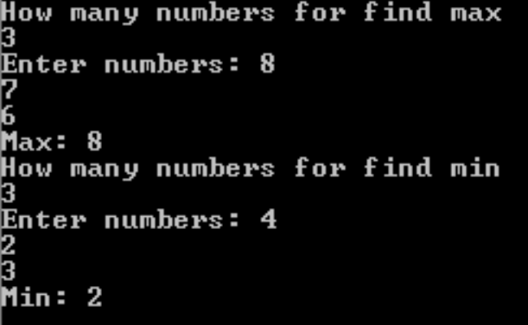

1. Write a code which will input a number which is more than one digit and check whether it is divisible by 2 or not.
2. Convert a decimal number into an octal number.

**Input:** 9

**Output:** 11

1. Take N input and find which one is even or odd. If even print ‘e’ else print ‘o’

**Input and Output:**

**7**

**9o4e6e1o5o2e7o**

**Important Note**

∙ Cheating or copying of assignments is strictly prohibited; both will get zero marks in that case.

∙ Viva will be taken**.**

**Submission Process:**   
**SUBMISSION DEADLINE: 3/9/2020**